OpenAgile Foundations

Foundation Three: The Learning Circle
“Learning is like rowing upstream: not to advance is to drop back.”

The Learning Circle is a simple and practical model of effective learning. This model describes learning as a series of four steps for us to follow, four capacities for us to develop, and the pivotal importance of Guidance. The steps are repeated over and over thus giving us the opportunity to get better at learning and to make progress. The Learning Circle model applies to traditional operations and project work as well as primary learning environments such as research and innovation.

The Four Steps
The four steps in the Learning Circle are Reflection, Learning, Planning, and Action, and are followed one after another, over and over. It is possible to begin an endeavour with any of the four steps. The diagram below shows the Learning Circle Model:

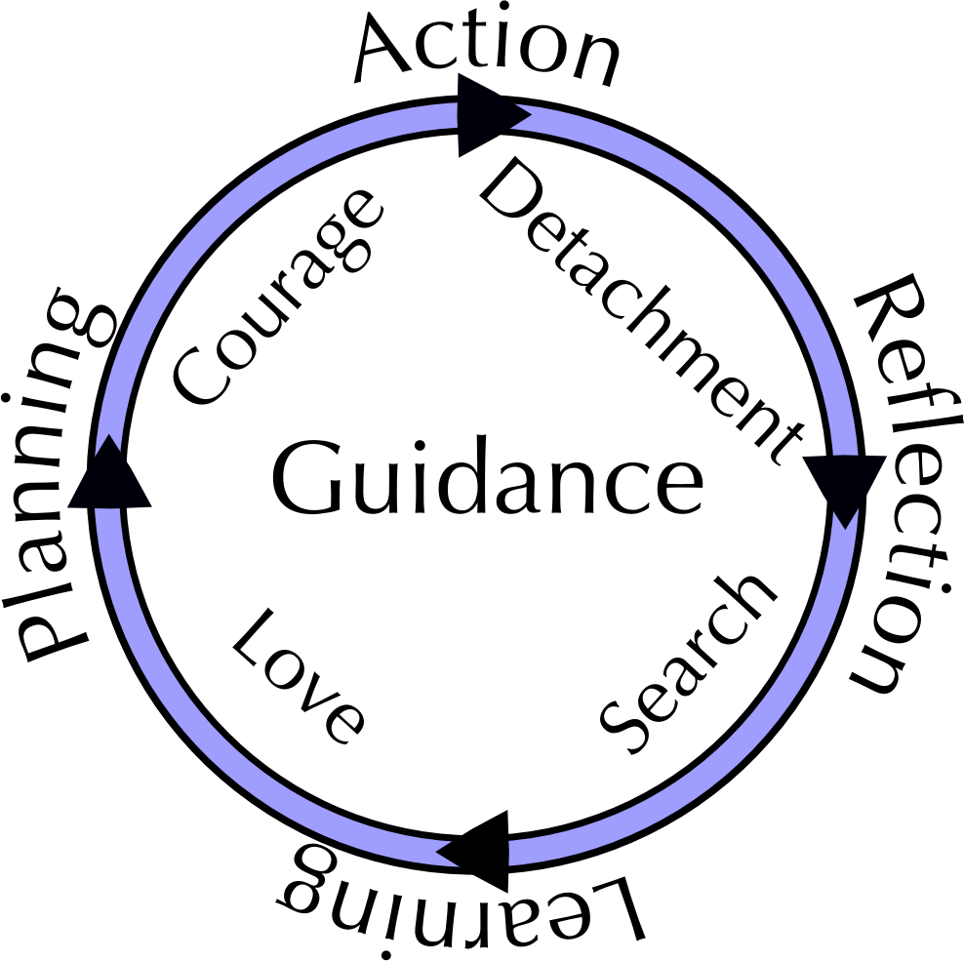

- Reflection
The Reflection step is a pause in our activities where we gather data, impressions, history, stories, and any other observations about what we have done. In order to do this effectively, we must develop and exercise the capacity for Detachment – detachment from preconceived notions.

- Learning
In the Learning step we carefully examine the observations made in the Reflection step and "discover" new insights, skills, relationships, structures, failures or any other conceptual changes. We search for the principles involved in our work. In order to do this effectively, we must develop and exercise the capacity of Search – search for the underlying principles.

- Planning
In the Planning Step we apply the conceptual understandings we have developed. We create a plan of action using the newly discovered principles from our learning step. We should directly reflect in our planning each insight or principle we have learned. In order to do this step effectively, we must develop and exercise the capacity for Love – love for the act of learning.

- Action
In the Action Step, as an individual, team, or organization we carry out the plans we have created. We do our work. In order to do this effectively, we must have Courage – courage to plunge into the unknown.

